Wizard Hat DM Screen Site Plan

Trevin Vallett

WDD 130

Overview

Purpose
Provide a reusable Dungeons and Dragons DM screen with interchangeable modules for the user to choose what information is displayed.

Audience
D&D players and Dungeon Masters

Branding

Website Logo
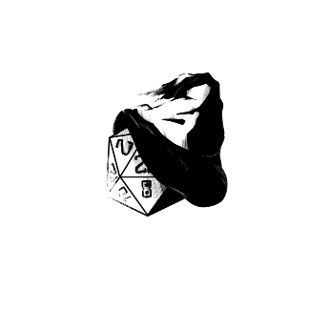

Style Guide

Color Palette (https://coolors.co/001524-15616d-ffecd1-896a67)
Primary | Secondary | Accent 1 | Accent 2
#FFECD1 | #001524 | #15616D | #896A67

Typography

Heading Font: Merriweather (https://fonts.google.com/specimen/Merriweather?lang=en_Latn), sans-serif [bold]

Alt Title/Heading Font: Bungee (https://fonts.google.com/specimen/Bungee?lang=en_Latn)

Paragraph Font: Verdana, sans-serif

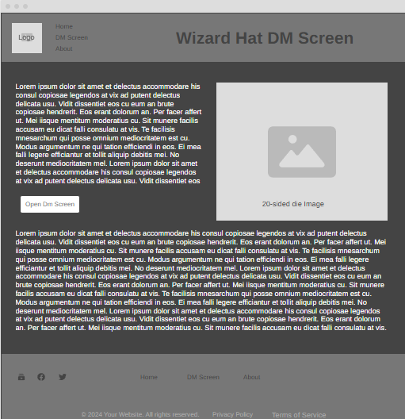

Navigation
Home DM Screen About

Content

--Home Page--
Top Left Paragraph:
Whether you are a player in a campaign or running the show, this is the tool you need. A customizable DM’s screen with 3 different sections to display whatever is needed. Player can use it to keep their items and notes orderly and easily accessible, while the Dungeon Master can have stat blocks on demand and little notes reminding them of the crazy adventure the players have been on. Sections can be opened and closed freely within highly responsive panels, meaning your information is always on demand. Give it a try using the button below!

Bottom Paragraph:
Dungeons and Dragons is a role-playing game designed to be played with 4-8 people sitting around a table. It uses stat sheets, acting, and the theater of the mind to create epic fantasy adventures. The original game using this format was called Chainmail and was far more complex, using actual letters and postage to send and receive messages, with vast battles using miniatures much like Warhammer: 40,000. The current version of dungeons and dragons is 5.5E, or D&D 2024, though the first edition was released back in 1977. Those who have played since at least the second edition of Dungeons and Dragons have gained the moniker Grognard. This comes from an old French word meaning grumpy, or old soldier. The precursor to Chainmail was several men role-playing being generals and soldiers in the Napoleonic wars, which is where the term Grognard began to be used in the genre. Both Chainmail and D&D have been written by Gary Gygax, with help from many others along the way. Since 2007 Jeremy Crawford from the publishing company Wizards of the Coast , has been answering questions about the rules, helping many players. The Dungeons and Dragons experience has been refined over decades of passionate labor, so gather a group of friends and give it a try!

--DM Screen Page--
Food:
While meals in Dungeons and Dragons may not provide sustainable bonuses without the Chef feat, it is a vital part of operations that could leave you in a bind if forgotten about. The pries of meals (as shown below) are not terribly high, though this chart presumes that food is of little to no issue to obtain. In places with harsh winters or that have recently been ransacked, the price may become astronomical, or perhaps there will simply be none for sale. Keep travel rations in mind, as long journeys to the next objective are frequently fraught with peril.

Meals
Squalid: 3cp
Poor: 5cp
Modest: 3sp
Wealthy: 8sp
Aristocratic: 2gp
Rations: 8cp

Weapons:
Swords, bows, clubs, and even guns can be a part of your arsenal depending on the setting. Weapons are the lifeblood of combat, allowing even low-level adventurers to dispatch enemy combatants. Whether playing a martial class or one with a greater focus on spellcasting, having some sort of weapon on you at all times is a must. Adventuring is not easy, and there are many out there who will make it even more difficult for you by causing a ruckus. Whether fighting back hoards of zombies, a coven of witches, or cutting the ropes that bind your allies, make sure you have something on hand.

Common Weapons
Club: 1sp
Dagger: 2gp
Quarterstaff: 2sp
Light Crossbow: 25gp
Longsword: 15gp
Rapier: 25gp
Longbow: 50gp

Trinkets:
Small items that are either important to your character or someone else in the world. Trinkets in D&D are small, curious items that have worth which can not be shown on a stat sheet. Perhaps it is a bag of pocket sand that seems to refill itself slowly, an insignia showing loyalty to the crown, or a small memento of a loved one. The effect of these trinkets are made by the role-playing that goes into them, they are as important or meaningless as you wish for them to be. Generally, having a memento or two for your character helps give them a more concrete background that other players can interact with.

Trinket Ideas:
Pocket lint that weighs more than it should
Small skull that seems to turn and follow movement
Key attached to a small lock that does not have a keyhole
Small translucent cube that plays an old English lecture
Canteen that makes a liquids inside vaguely cherry flavored
Compass that points toward the bearer at all times

Armor:
The best way to keep oneself alive during a fight has been and always will be armor. Many of the types get rather expensive, but they are worth every copper spent. Provided the character is proficient in the armor, they can wear it without issue. Some characters prefer a light armor, allowing for their Dexterity to be useful in dodging attacks. Others prefer to find the heaviest metal they can find and drape it over themselves, becoming a highly deadly onion-shaped warrior. So long as you have the money and Strength score for it, armor is a must for every class.

Common Armors:
Leather: 5gp
Studded Leather: 45gp
Scale Mail: 50gp
Breastplate: 400gp
Plate: 1,500gp

Supplies:
Combat is not the only focus of adventuring. Far more often than not, there will be traps, trials and tricks that must be solved through the creative use of tools and personal cunning. Many items exits to help the players in sticky situations where the sword will do no good. Some of the good become a bit pricy, but all costs are worth it if they keeps you alive. Depending on the town you are in, what they produce and general availability of the setting prices may change, but the following are the basic prices for sever common items you might need along your travels.

Common Items:
Bedroll: 1gp
Map: 4gp
Iron Pot: 2gp
Torch: 1cp
Caltrops(20): 1gp
Crowbar: 2gp
Ladder(10ft.): 1sp
Hempen Rope(50ft.): 1gp
Backpack: 2gp
Tinderbox: 5sp

--About--
We here at Wizard Hat are always looking for feedback on how to improve the website. Put in your name, email, and message you would like to send us. It will be read over by a real human being and perhaps implemented to the website for the sake of user experience. We enjoy working on these projects and are always looking for ways to improve, especially as college students who could always use a little more on a resume. We appreciate the time you take to help us out.

Wireframes

Home


DM Screen

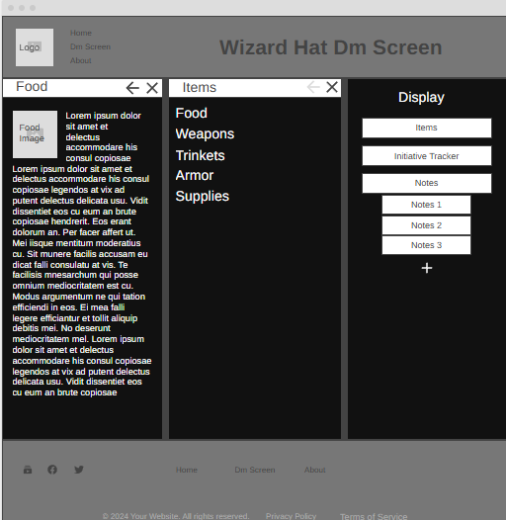

The Notes section is meant to create a new notes page each time the plus button is clicked. If that does not seem reasonable, just removing it and making a single notes section is quite alright.

Initiative tracker is just a blank screen (with the little top bar) with boxes to put in names and initiative numbers, with a little plus button below to add a new box in below. Draggable for re-ordering would be preferable.

About

